We Are In Very Great Danger! But There Is Hope, If…
February 13, 2018

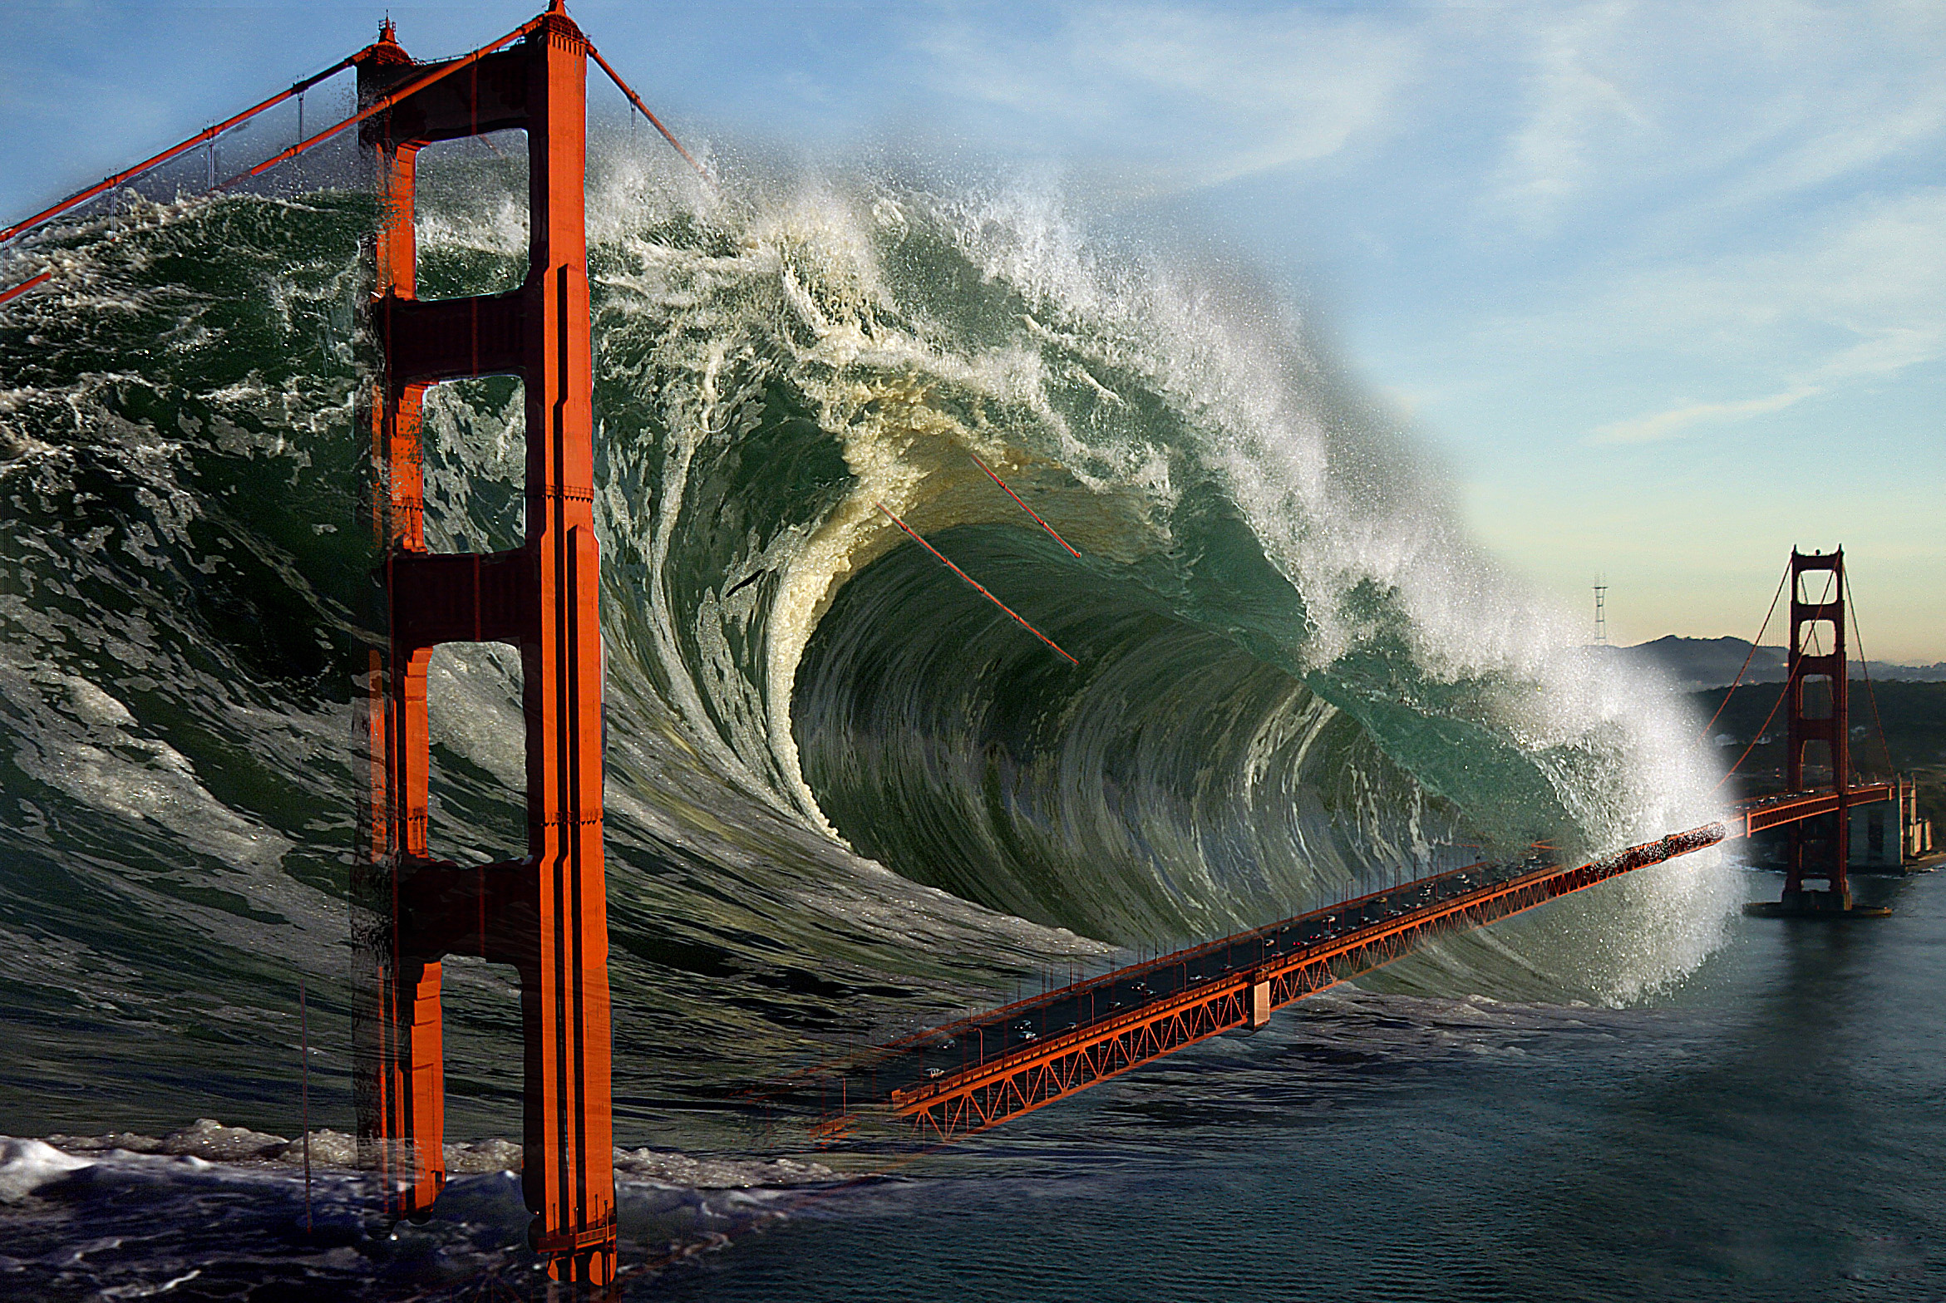
Dear Lord and Father God, please don’t let them do what they want to do to destroy the world.

Please, Jesus, Father God and Holy Spirit—please supernaturally intervene. Let the wickedness of the rulers backfire on their own turf, that nothing drastic must be done to stop them. Let the ruthless fall into their own traps and set our country free of this Satanic grip.

Oh, Father God, protect our nation as long as Trump is in office, or those who love righteousness are working to undo the evil agendas that have been set in place over the last 40 years.

Please, Father God, have mercy.

And that's my cry, dear Heartdwellers. Some of you are STILL experiencing a lot of opposition and a lot of difficulty. And I have to tell you: this is about intercession. And many of you on this Channel are intercessors and have given your lives to the Lord. And made your bodies living sacrifices to the Lord. Many of you have given everything to Him. And right now, He's calling upon you to offer up your sufferings for the situation in the world, which is very, very distressing. And my heart aches with the possibilities that the Deep State wants to use against us.

Perry Stone, for instance, has had many dreams about a city with a beautiful bridge being blown up. The bridge being blown up at the base and then a huge tsunami coming in. We, too, have shared dreams with you about San Francisco and NYC. And I have to say that Deep State has the technology to do these things.

In Perry's vision, he saw the twin towers arising up out of the tsunami, and he interpreted that to mean that this would be an act of terrorism. But we all know that Obama and the Deep State are having access to, and supporting that. So, our prayers are really, really needed right now.

The evil rulers of this age have this technology to set off tsunamis and fault lines to destroy these two cities—New York and San Francisco. But apparently, they want to blow the bridge up from the base, and make it look like a tsunami took it out. But that's not what it's about. It's about terrorism, the same way with 9/11—the way that building was rigged to blow up at every floor, synchronistically. And that's the same thing they want to do with this bridge and this city.

And being hot on the trail—Trump being hot on the trail of all these people that have perverted what is right over these years has really brought down the wrath. They want to do ANYTHING, and they will do anything—without any sense of conscience—to hurt whoever they have to hurt, to get the job done. To bring this country down.

But we have a president who is changing things. If only we will vote in a Republican party in every election we have access to; if only we will do this—changes can happen. Right now, it's the Democrats that are holding up everything. The Democrats who are sold out to the New World Order. The Democrats who want to see the destruction of this country. But we have the power in our own hands to change this. Through prayer. Through educating other people. And through action. Being sure that we're registered to vote and we vote in the next elections that come up. If we will do this, changes can happen, mercy can be given and these horrendous prophecies do not have to be witnessed, perhaps until after the Rapture.

We are not given these dreams to brag about our prophetic gifts; we are given these dreams to warn people and pray for repentance and pray against this judgment falling, especially before the Rapture. Prayer changes things! These dreams are not just to lay down with. These dreams are to cause us to rise up, and repent for the nation, and pray for change.

Lord, please forgive me if I am wrong. But please, dear God, can’t our prayers do something to prevent these things from coming true?

Jesus began, “My dear Bride, I know your plate has been full of sorrows, and progress in many areas, as well. And I know you grieve for what could soon happen. We grieve as well.

"My Father grieves with Me and My Holy Spirit—but some things cannot be totally averted. Nevertheless, your prayers are powerful and We do hear them. And We do consider them. And We do make changes to accommodate your prayers.

"Yes, Our hearts are breaking with looming tragedies that will take innocent lives; We cry over the very thought of these. Please. Please do press in and pray!

“What can be done? Yes, you can pray with all your hearts that these things can be lessened, averted or postponed—and again I tell you, your prayers are heard in Heaven. Satan has many plans for the Earth, many of them have already come to fruition. But I tell you again: your prayers are powerful and My Father is STILL in complete control of what will happen here.

“Your prayers are powerful! Think of the loss of innocent lives and pray, pray, pray for Mercy. Pray that wickedness in high places will be thwarted. Pray that your nation will wake up and see what this President has done that is so good.

"Pray that the uninformed ones will see evil puts on a pretty face, a pretty face, a handsome face. Evil says many things people like to hear. Evil deceives—and the American people have been duped because they were not paying attention.

“Pray that they wake up, My People, and do your part to expose evil. There is still hope. You are not past the point of no return; there is hope. But it is the power of your prayers, your votes, and your ability to inform the ignorant that will accomplish the greatest good for America and the world.

“Do your parts and We will do Ours.”

